My Passport to Upper School Spelling!

Name: ______________
Class: ______________

Strategies to aid the learning of spelling words
Look, cover, write. check | This is probably the most common strategy used to learn spellings.  Look: first look at the whole word carefully and if there is one part of the word that is difficult, look at that part in more detail.  Say: say the word as you look at it, using different ways of pronouncing it if that will make it more memorable.  Cover: cover the word.  Write: write the word from memory, saying the word as you do so.  Check: Have you got it right? If yes, try writing it again and again! If not, start again – look, say, cover, write, check.
Trace copy and replicate (and check) | This is a similar learning process to ‘look, say, cover, write, check’ but is about developing automaticity and muscle memory. Write the word out on a sheet of paper ensuring that it is spelt correctly and it is large enough to trace over. Trace over the word and say it at the same time. Move next to the word you have just written and write it out as you say it. Turn the page over and write the word as you say it, and then check that you have spelt it correctly. If this is easy, do the same process for two different words at the same time. Once you have written all your words this way and feel confident, miss out the tracing and copying or the tracing alone and just write the words.
Segmentation Strategy | The splitting of a word into its constituent phonemes in the correct order to support spelling.
Quickwrite | Writing the words linked to the teaching focus with speed and fluency. The aim is to write as many words as possible within a time constraint.  Pupils can write words provided by the teacher or generate their own examples. For example, in two minutes write as many words as possible with the /iː/ phoneme.  This can be turned into a variety of competitive games including working in teams and developing relay race approaches.
Draw around the word to show the shape | Draw around the words making a clear distinction in size where there are ascenders and descenders. Look carefully at the shape of the word and the letters in each box. Now try to write the word making sure that you get the same shape.  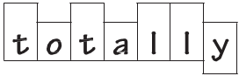
Drawing an image around the word | This strategy is all about making a word memorable. It links to meaning in order to try to make the spelling noticeable.  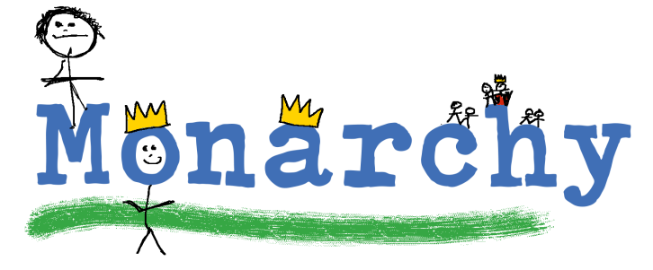  You can’t use this method as your main method of learning spellings, but it  might work on those that are just a little more difficult to remember.
Words without vowels | This strategy is useful where the vowel choices are the challenge in the words. Write the words without the vowels and pupils have to choose the correct grapheme to put in the space. For example, for the word field:  
Pyramid words | This method of learning words forces you to think of each letter separately.  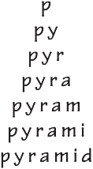  You can then reverse the process so that you end up with a diamond.
Other strategies | Other methods can include:  - Rainbow writing. Using coloured pencils in different ways can help to make parts of words memorable. You could highlight the tricky part s of the word or write the tricky part in a different colour. You could also write each letter in a different colour, or write the word in red, then overlay in orange, yellow and so on.  - Making up memorable ‘silly sentences’ containing the word  - Saying the word in a funny way – for example, pronouncing the ‘silent’ letters in a word  - Clapping and counting to identify the syllables in a word.

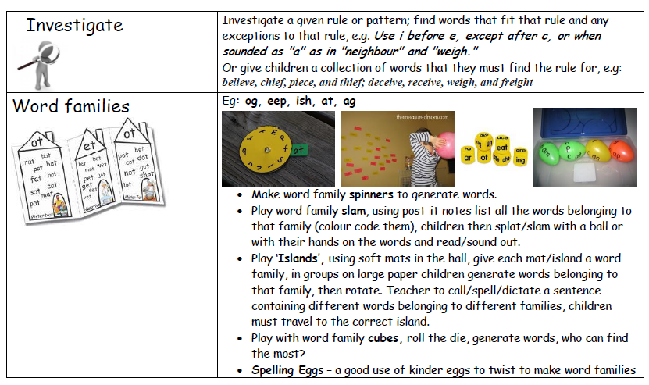
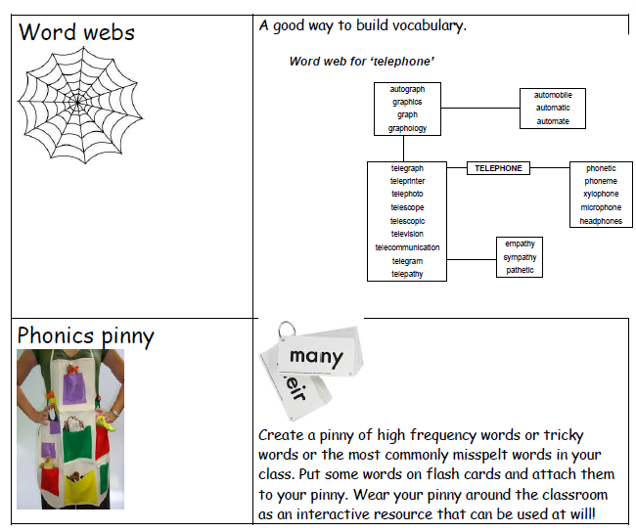
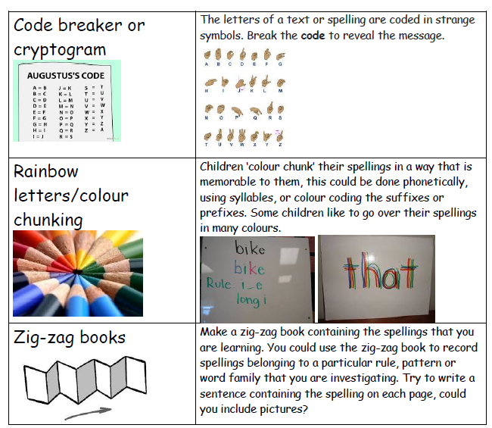

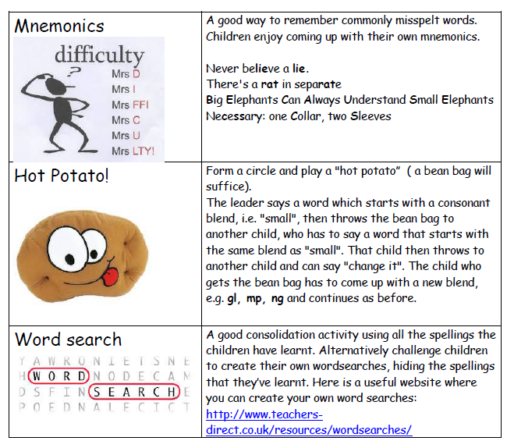
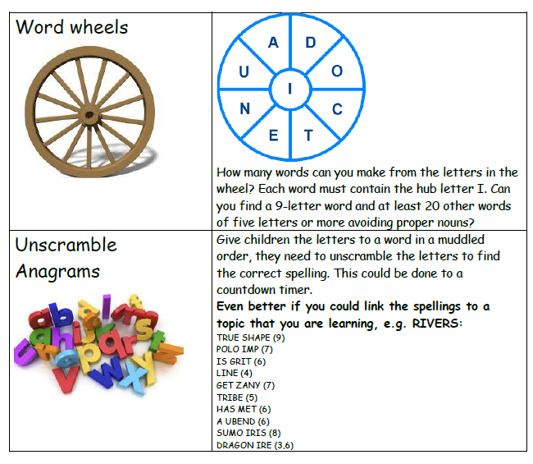
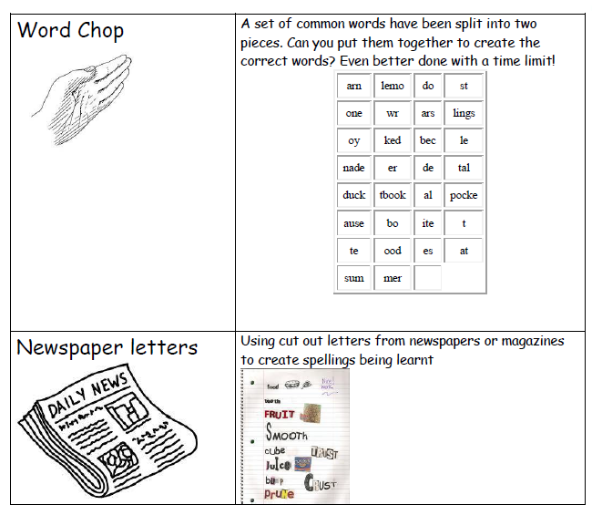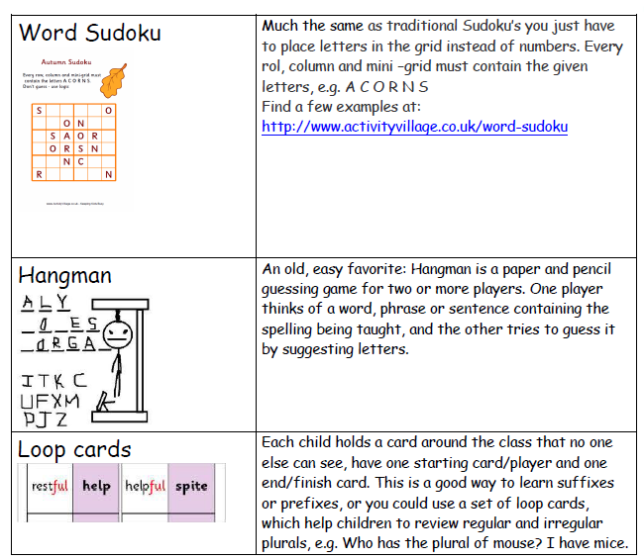

Target  Word from Statutory list | My spelling strategy that will help me remember… | Adult at home:  date when you think your child can spell the word and understands the meaning
accommodate
accompany
according
achieve
aggressive
amateur
ancient
apparent
appreciate
attached
available
average
awkward
bargain
bruise
category
cemetery
committee
communicate
community
competition
conscience
conscious
controversy
convenience
correspond
criticise (critic + ise)
curiosity
definite
desperate
determined
develop
dictionary
disastrous
embarrass
environment
equip (-ped, -ment)
especially
exaggerate
excellent
existence
explanation
familiar
foreign
forty
frequently
government
guarantee
harass
hindrance
identity
immediately
interfere
interrupt
language
leisure
lightning
marvellous
mischievous
muscle
necessary
neighbour
nuisance
occupy
occur
opportunity
parliament
persuade
physical
prejudice
privilege
profession
programme
pronunciation
queue
recognise
recommend
restaurant
rhyme
rhythm
sacrifice
secretary
shoulder
signature
sincere(ly)
soldier
stomach
sufficient
suggest
symbol
system
temperature
thorough
twelfth
variety
vegetable
vehicle
yacht

