Reading Overview: Year 3
Autumn 1 | Autumn 2 | Spring 1 | Spring 2 | Summer 1 | Summer 2
Into the Past … with a Twist!  (linked to history topic) | A whole new world …  (Robots/AI) | Making a Difference  (environment) | Making connections … | The Olden Days & Joy in Words …  (Literary Heritage & poetry) | Through the Books …  (Author Study)
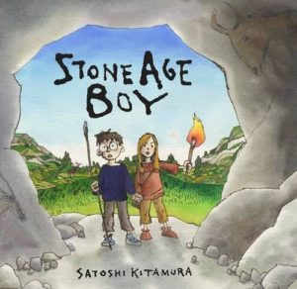 | 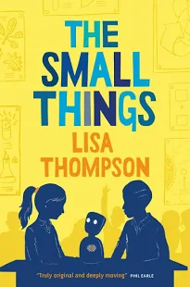 | 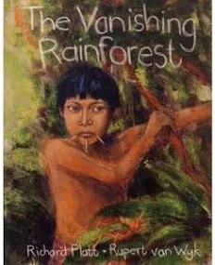 | 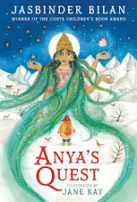 | 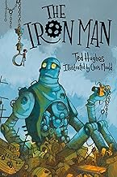 | 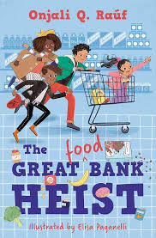
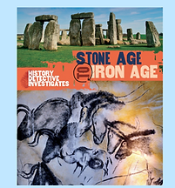 | 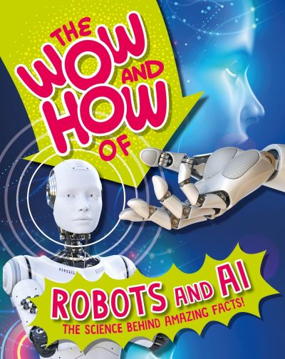 | 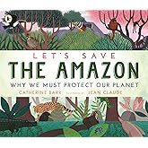 | 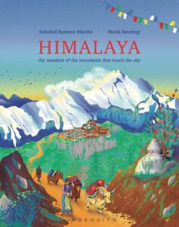 | 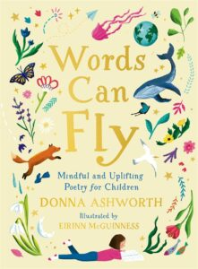 | 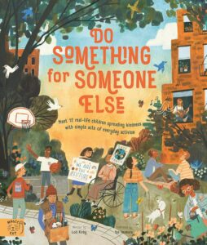

Reading Overview: Year 4
Autumn 1 | Autumn 2 | Spring 1 | Spring 2 | Summer 1 | Summer 2
Into the Past … with a Twist!  (linked to history topic) | A whole new world …  (Robots/AI) | Making a Difference  (environment) | Making connections …  (Hindu & Islam main characters/stories) | The Olden Days & Joy in Words …  (Literary Heritage & poetry) | Through the Books …  (Author Study)
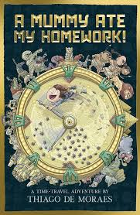 | 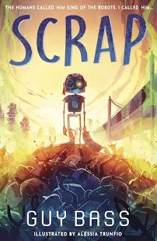 | 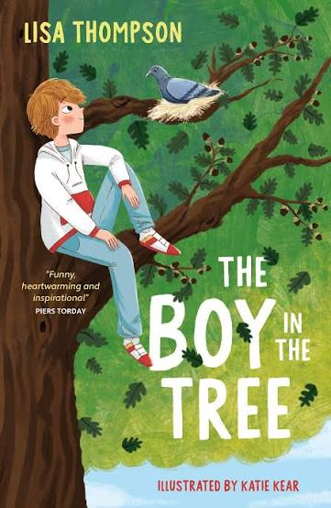 | 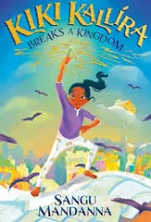  Has river | 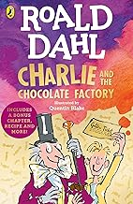 | 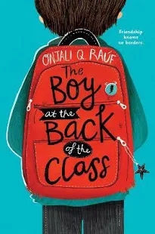
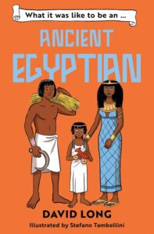 | 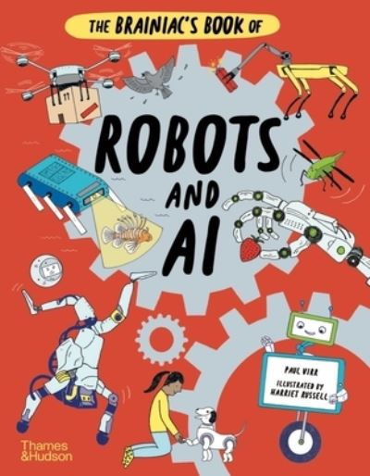 | 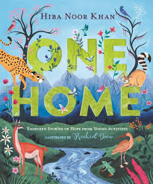 | 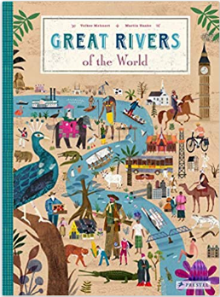 | 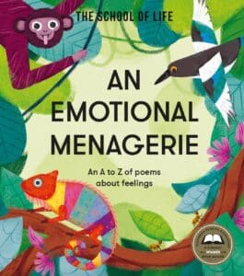 | 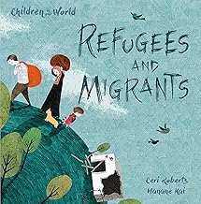

Reading Overview: Year 5
Autumn 1 | Autumn 2 | Spring 1 | Spring 2 | Summer 1 | Summer 2
Into the Past … with a Twist!  (linked to history topic) | A whole new world …  (Robots/AI) | Making a Difference  (environment) | Making connections …  (Hindu & Islam main characters/stories) | The Olden Days & Joy in Words …  (Literary Heritage & poetry) | Through the Books …  (Author Study)
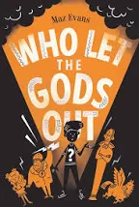 | 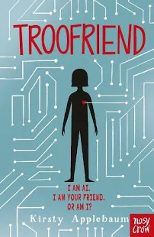 | 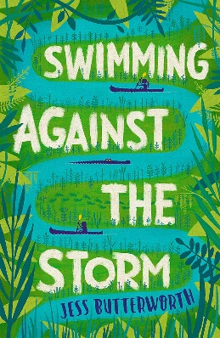 | 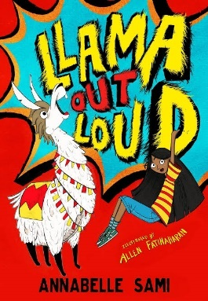 | 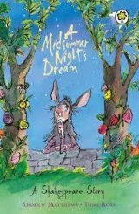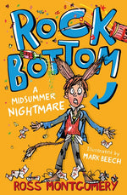 | 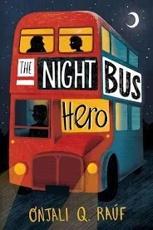
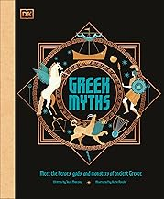 | 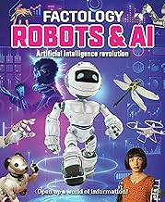 | 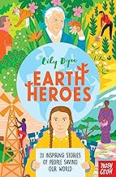 | 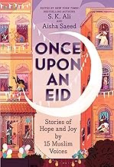 | 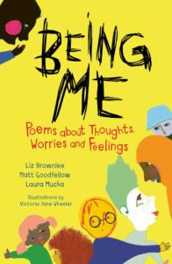 | 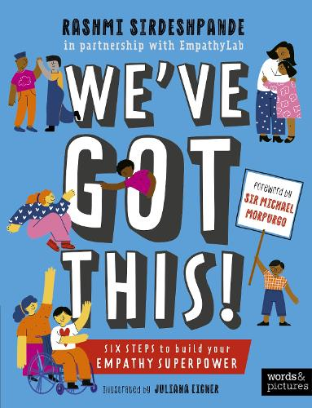

Reading Overview: Year 6
Autumn 1 | Autumn 2 | Spring 1 | Spring 2 | Summer 1 | Summer 2
Into the Past … with a Twist!  (linked to history topic) | A whole new world …  (Robots/AI) | Making a Difference  (environment) | Making connections …  (Hindu & Islam main characters/stories) | The Olden Days & Joy in Words …  (Literary Heritage & poetry) | Through the Books …  (Author Study)
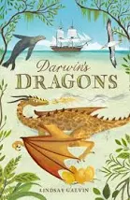 | 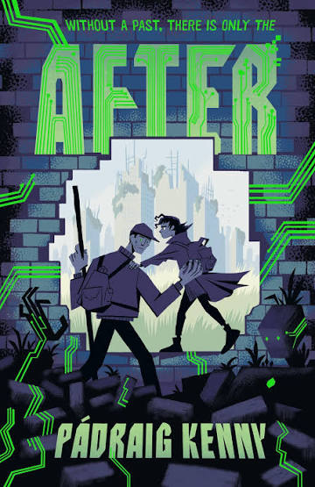 | 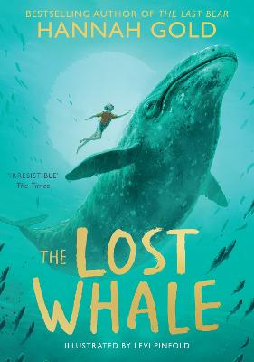 | 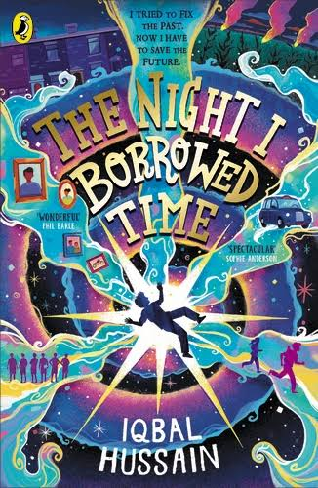 | 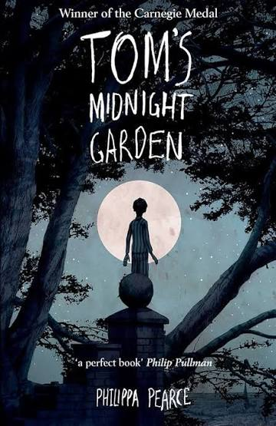 | 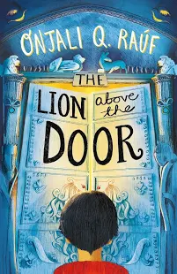
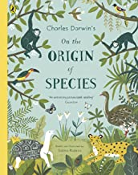 | 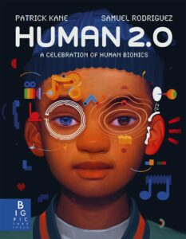 | 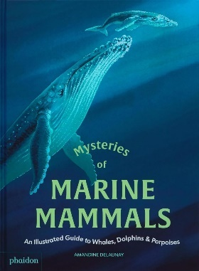 | 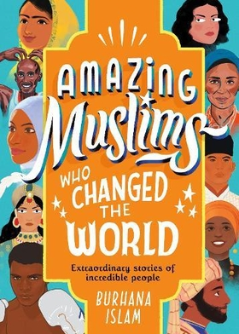 | 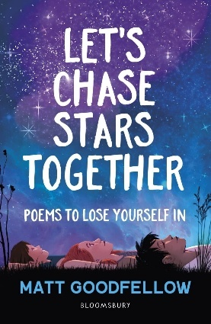 | 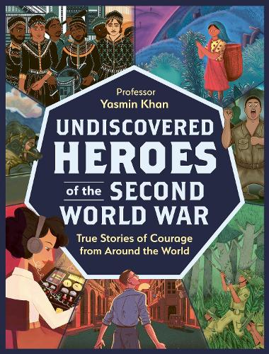

Connections & Themes
What books to order

