
Long Term Overview – Writing Year 3

Focus: Secure sentence construction and basic text forms
 | Autumn 1st | Autumn 2nd | Spring 1st | Spring 2nd | Summer 1st | Summer 2nd
 | Developing descriptive language |  | Sequencing and recount |  | Information and sustained writing
Suggested text driver | 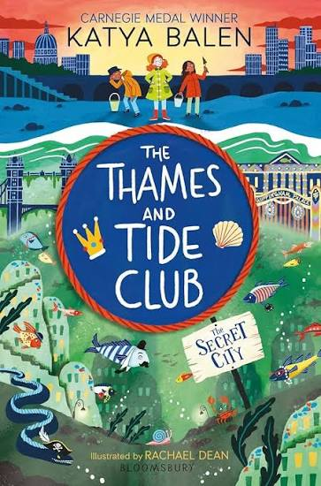 |  | 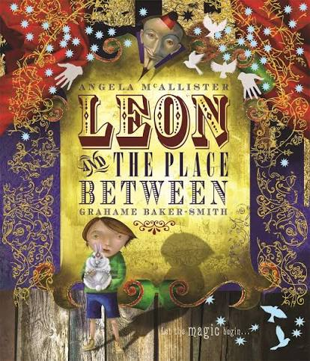 | 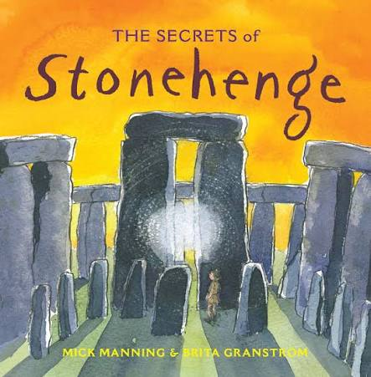 | 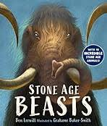 | 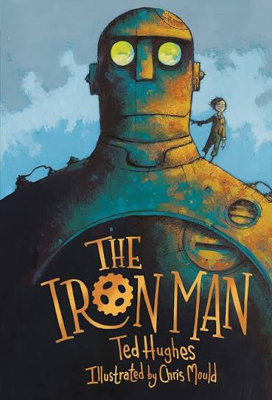
Genre | Setting descriptions  ** | Character descriptions | Story openings | 1st person recount  Link to Butser trip | Non-Chronological reports | Diary recount
Progression focus | Create simple settings using expanded noun phrases and sensory detail. | Use expanded noun phrases and precise vocabulary to describe appearance and behaviour. | Create engaging story openings and sequence events logically. | Write chronological first-person recounts using time adverbials. | Present factual information under headings and grouped sections. | Sustain chronological first-person recount writing across a longer sequence of events.
Suggested text driver | 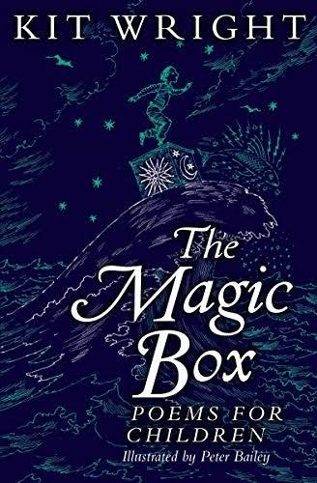 | 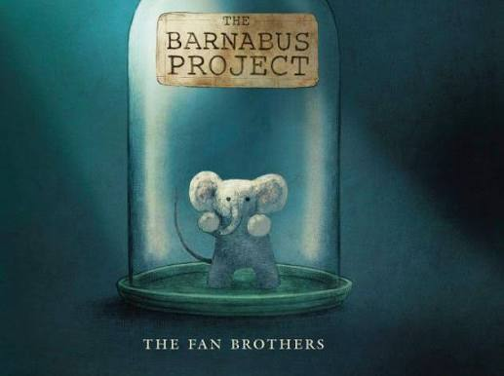 | 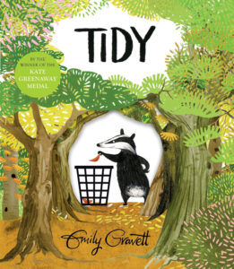 |  | 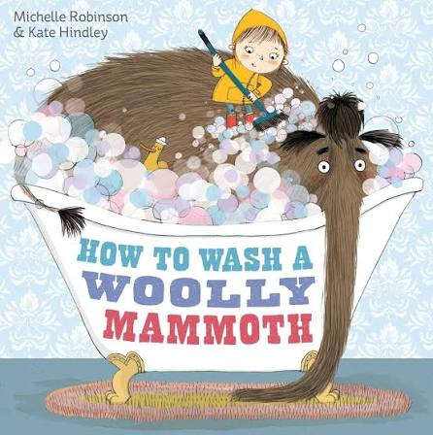 | 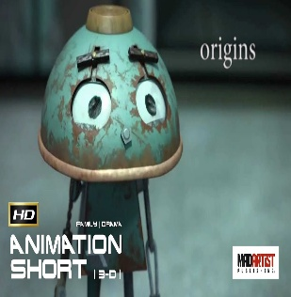
Genre | Poetry | Animal fact-files | Persuasive poster  Real-life campaign: "Protect Our School Environment" | Diary recount | Instructions | Simple narrative
Progression focus | Use pattern, repetition and simple structures. | Present factual information using labels and simple headings. | Express opinions with simple reasons. | Write chronological first-person diary entries using time adverbial | Use commands, sequencing and imperative verbs. | Write narratives with clear beginnings, middles and endings, applying description and sequencing independently.

Long Term Overview – Writing Year 4

Focus: Develop cohesion and paragraph control across forms
 | Autumn 1st | Autumn 2nd | Spring 1st | Spring 2nd | Summer 1st | Summer 2nd
 | Paragraphing and organisation |  | Developing cohesion and structure |  | Applying organisational features
Suggested text driver | 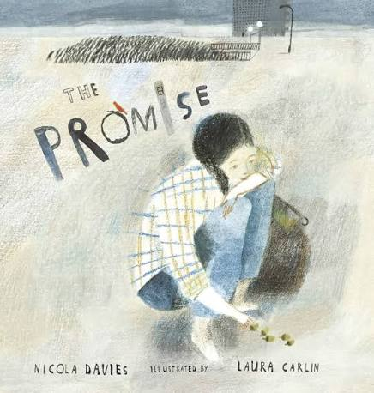 | 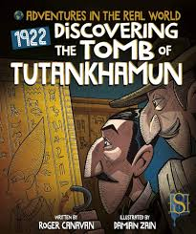 | 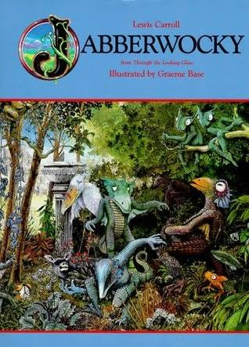 | 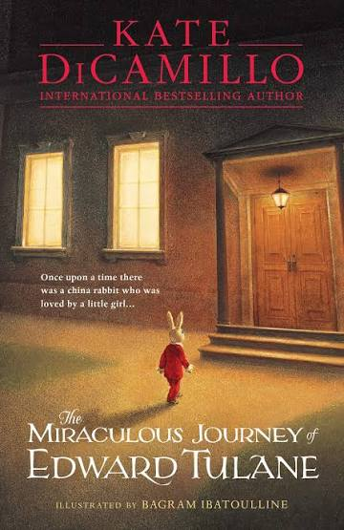 | 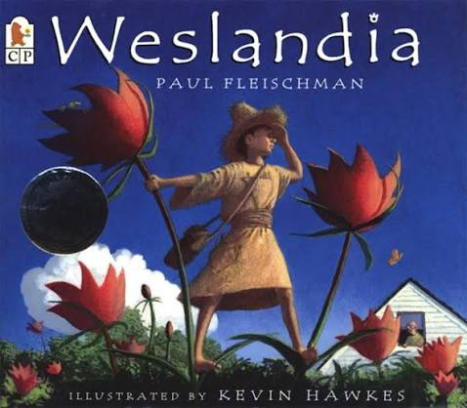 | 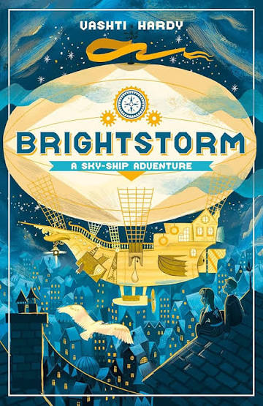
Genre | Narrative | Diary | Poetry | Narrative | Persuasive brochure | Diary
Progression focus | Develop character and setting through description, action and dialogue. Begin to organise ideas into paragraphs | Include thoughts, feelings and reflection. Organise writing into paragraphs | Experiment with vocabulary, imagery and poetic forms | Develop character through action and speech. Paragraphs to organise narrative | Organise information and viewpoints using paragraphs, organisational features and topic sentences. | Develop thoughts, feelings and character reflection whilst organising writing into paragraphs
Suggested text driver | 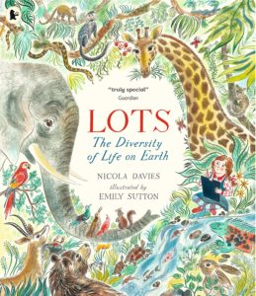  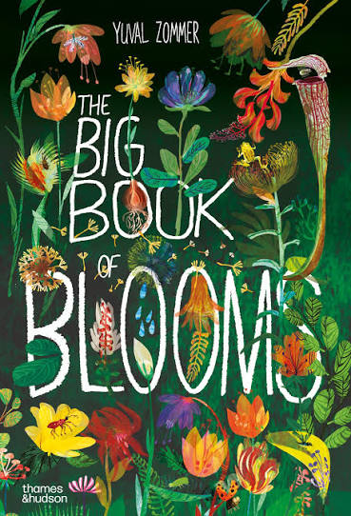 | 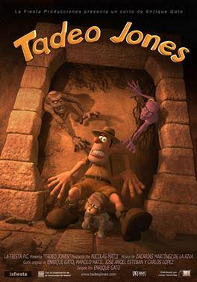 | 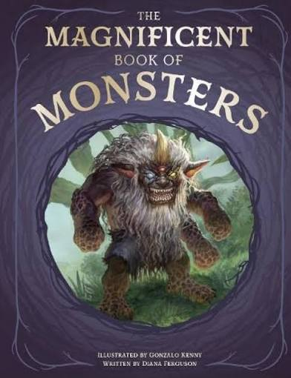 | 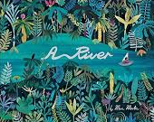  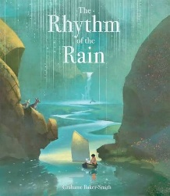 | 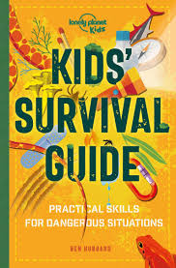
Genre | Non-Chronological report  Linked to local area visit to find out about diversity of animals in local area. | Character & Setting description | Non-Chronological report | Persuasive poster  Linked to river visit and environment – Protect our rivers | Instructions | Formal & Informal letters
Progression focus | Use paragraphs, organisational devices, technical vocabulary and topic sentences | Develop use of precise vocabulary and paragraphing. | Organise ideas into paragraphs and organisational features. Topic sentences. | Organise persuasive arguments into clear sections using appropriate organisational features | Organise detailed procedural writing using clear sequencing and organisational features. | Identify and apply the organisational and language features of formal and informal letters.

Long Term Overview – Writing Year 5

Focus: Write with awareness of audience and purpose
 | Autumn 1st | Autumn 2nd | Spring 1st | Spring 2nd | Summer 1st | Summer 2nd
 | Understanding audience |  | Writing for purpose |  | Adapting for audience and effect
Suggested text driver | 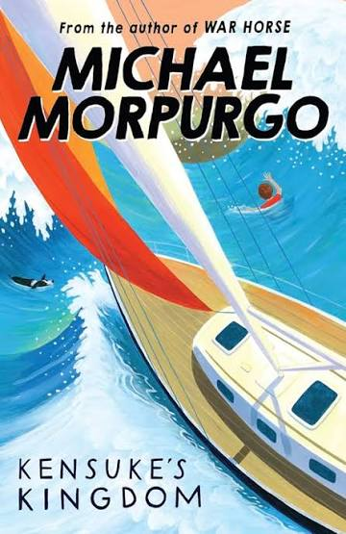 | 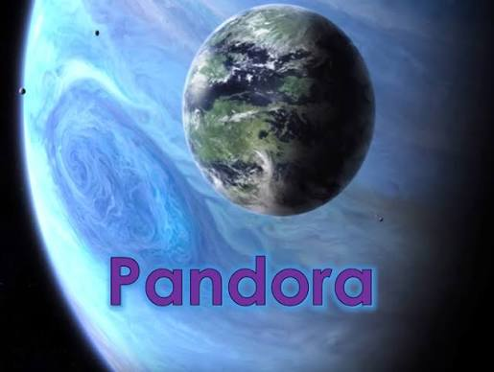 |  | 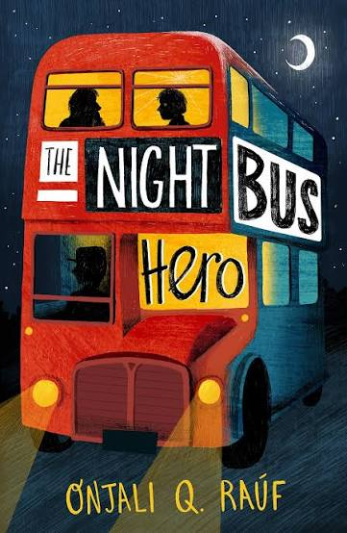 | 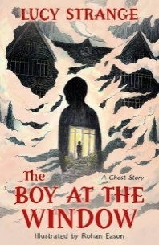  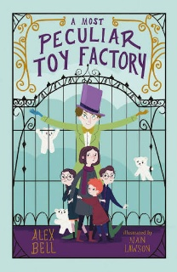 | 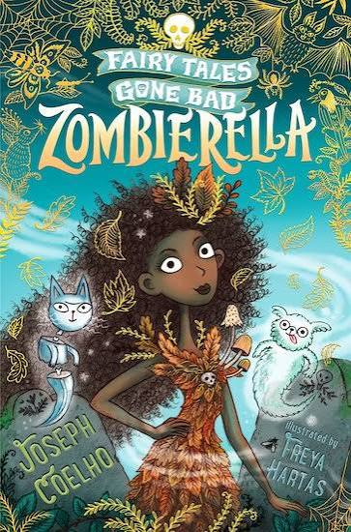
Genre | Diary | Non-chronological report | Narrative | Diary | Narrative | Narrative
Progression focus | Develop awareness of audience through multiple emotions and motivations. | Select content and vocabulary appropriate to audience and purpose | Integrate character and setting description deliberately to influence the reader and move the narrative forward. | Adapt diary writing to engage the reader whilst revealing multiple emotions and motivations. | Develop atmosphere and suspense. Select details deliberately. | Manipulate viewpoint and tension for effect and develop atmosphere and suspense. Select details deliberately
Suggested text driver |  | 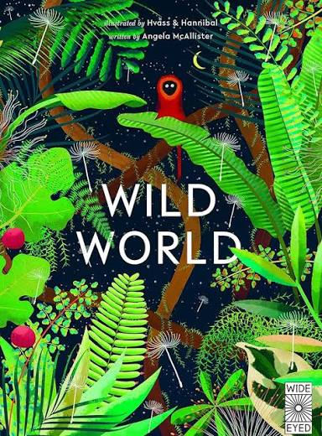 | 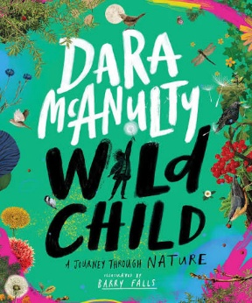 |  | 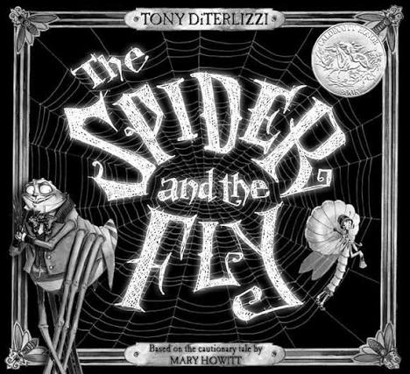 | 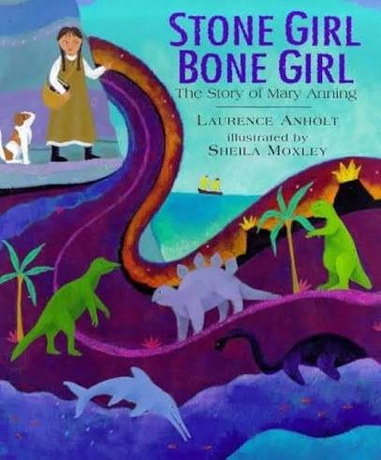
Genre | Informal letter  Letter from Michael to a friend or parents describing life on the island. | Poetry | Persuasive leaflet  Linked to residential - Welcome to Stubbington Study Centre. Focus on animals, habitats, adventure etc . | Newspaper | Formal/informal letter as character | Explanation  Linked to science: Either circulation or fossil formation.
Progression focus | Adapt language and content for an identified audience | Use figurative language and imagery to create a deliberate effect on the reader. | Select persuasive techniques appropriate to audience and purpose. | Use newspaper conventions including quotes whilst considering audience and purpose | Adapt language and structure for different audiences | Explain processes clearly, selecting technical vocabulary appropriate to audience and purpose

Long Term Overview – Writing Year 6

Focus: Write independently with control, selecting form and voice appropriately
 | Autumn 1st | Autumn 2nd | Spring 1st | Spring 2nd | Summer 1st | Summer 2nd
 | Voice and Viewpoint |  | Controlling Reader Response |  | Independent Authorial Control
Suggested text driver |  | 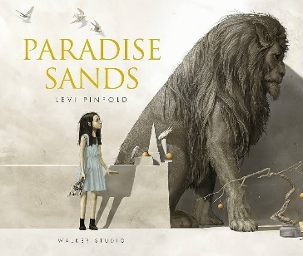 |  |  | 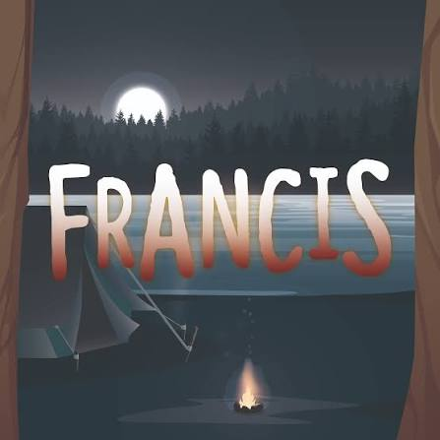 | 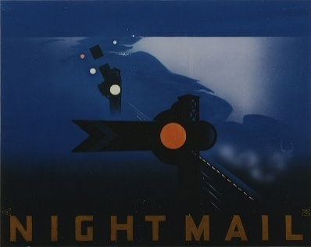
Genre | Narrative  Writing as Alma and one of the dolls for different viewpoint (1st / 3rd Person) | Narrative – Prequel | Newspaper report | Biography | Newspaper report | Poetry
Progression focus | Manipulate viewpoint to shape reader response. | Control narrative structure and authorial choices independently. | Select journalistic techniques deliberately to influence the reader. | Independently select and combine organisational structures appropriate to purpose and audience. | Select and present information strategically to shape reader interpretation. | Craft and control for impact. Deliberate poetic effect
Suggested text driver | 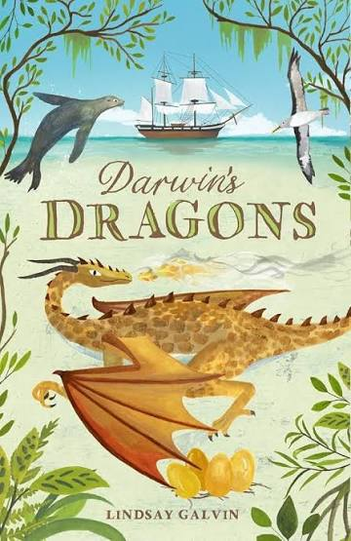 | 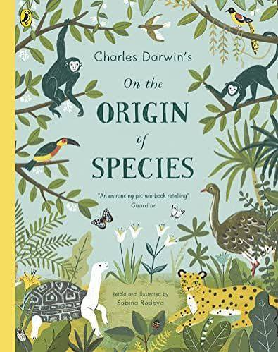 | 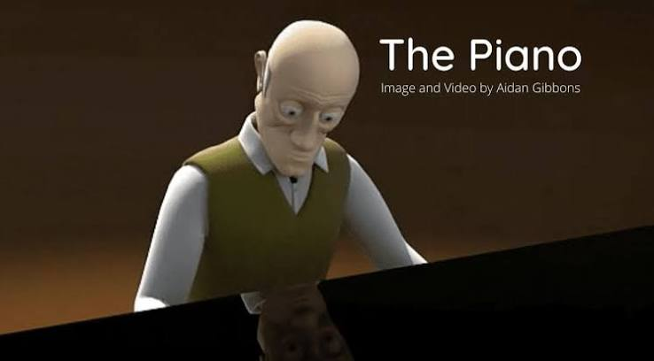 | 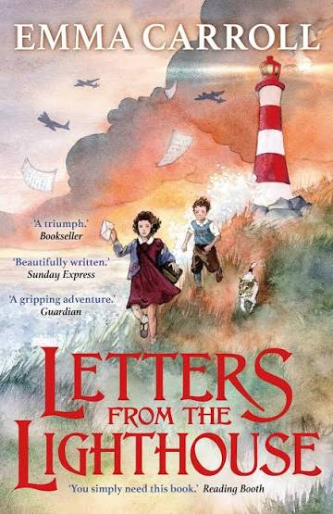  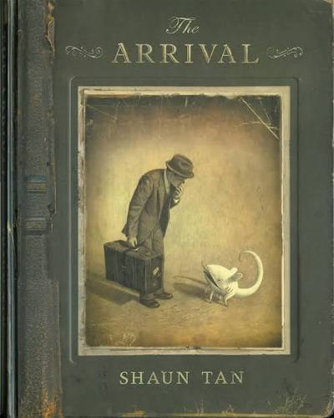 | 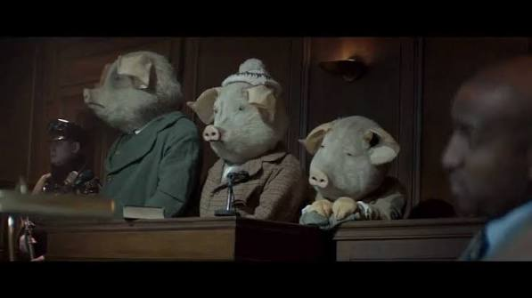 | 
Genre | Diary | Explanation | Narrative flashback | Persuasive – Visitors guide | Police Statement, personal statement, letter, speech | Multi genre choice: e.g. speech for yr5, memoir, letter to future self, guide to starting Year 7
Progression focus | Reflective inner monologue and complex viewpoint. Control narrative voice. | Independently select structure, vocabulary and supporting detail to explain complex concepts effectively. | Control reader response through deliberate authorial choices. | Manipulate tone, viewpoint and evidence to persuade effectively. | Deliberately manipulate register, formality and voice for impact. | Independently select and manipulate form, structure, voice and language choices to achieve a chosen purpose.

