
Long term overview – History

 | Autumn 1st | Autumn 2nd | Spring 1st | Spring 2nd | Summer 1st | Summer 2nd
Year 3 |  |  | 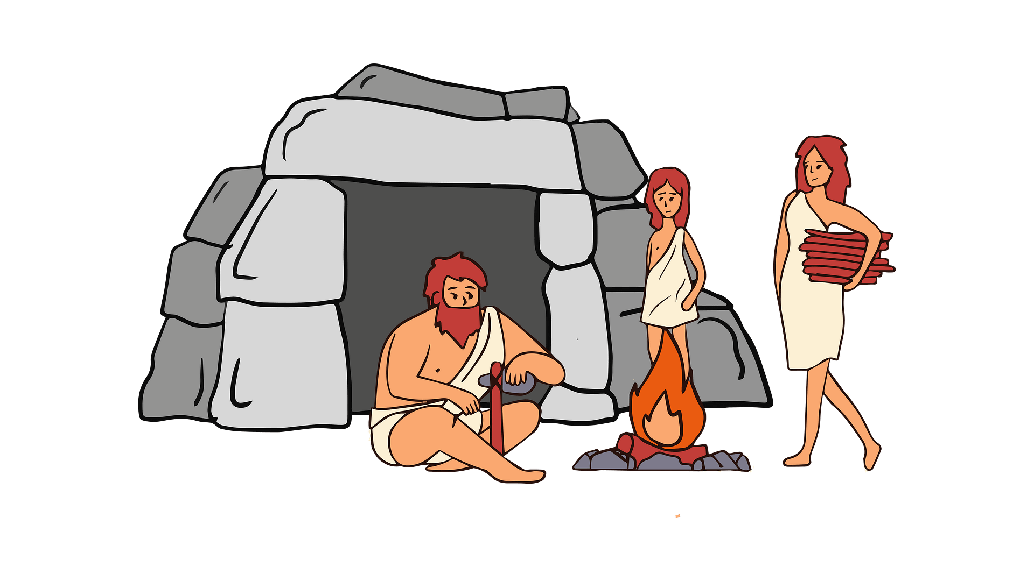  British history: Would you prefer to have lived in the Stone Age, Bronze Age or Iron Age? |  | British history: Why did the Romans invade and settle in Britain?  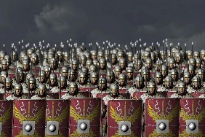
Year 4 | What was important to the ancient Egyptians?  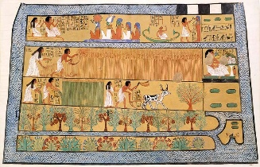 |  | British history: What changed in Britain after the Anglo-Saxon invasion?  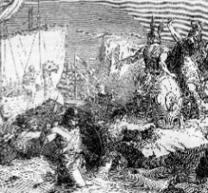 |  | How did the achievements of the ancient Maya impact their society and beyond?  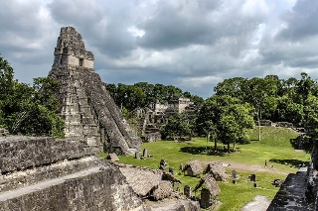
Year 5 | British history: Were the Vikings raiders, trades or something else?  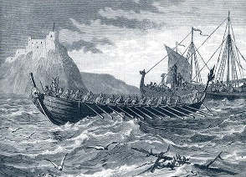 |  | British history: What was life like in Tudor England?  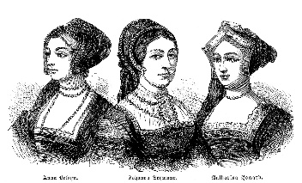 |  | What was the legacy of the ancient Greek civilization?  
Year 6 | What was the impact of World War 2 on the people of Britain?  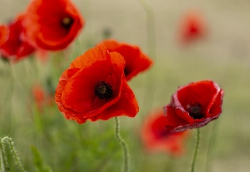 |  | What can the census tell us about the local area?  

