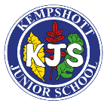
Long term overview – Art

 | Autumn 1st | Autumn 2nd | Spring 1st | Spring 2nd | Summer 1st | Summer 2nd
Year 3 | 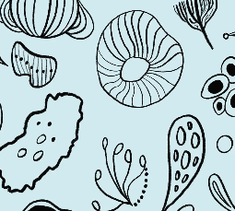  Developing drawing skills |  | Painting and mixed media: Prehistoric painting  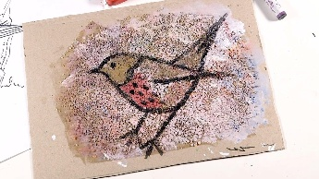 |  | Sculpture and 3D: Mega matrerials  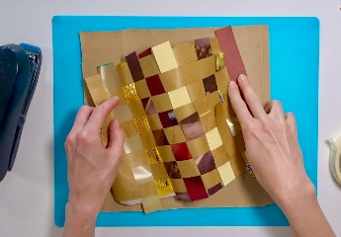
Year 4 |  | Craft and design: Fabric of nature  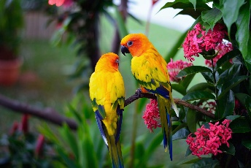 |  | Drawing: Exploring, tone, texture and proportion  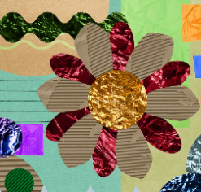 | 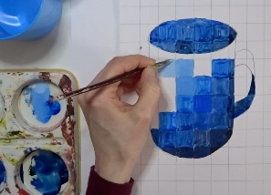  Painting and mixed media: Light and dark
Year 5 | 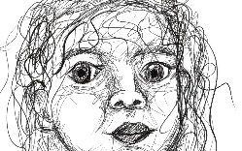  Drawing: Depth, emotion and movement |  |  | 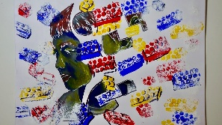  Painting and mixed media: Portraits |  | 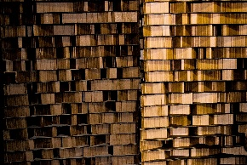  Sculpture: Making memories
Year 6 |  | Drawing: Expressing ideas  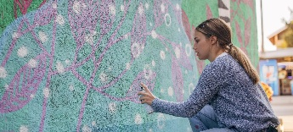 |  | Painting and mixed media: Artist study  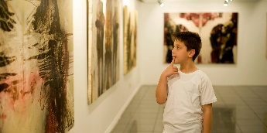 |  | Craft and design: Photos  