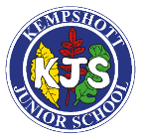
Long term overview – Science

 | Autumn 1st | Autumn 2nd |  | Spring 1st | Spring 2nd | Summer 1st |  | Summer 2nd
Year 3 | Light  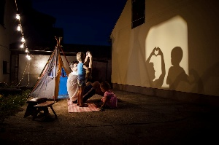 | Rocks and soils  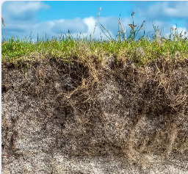 |  | Magnets  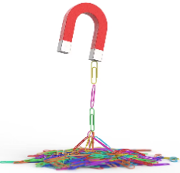 | Animals, skeletons and movement  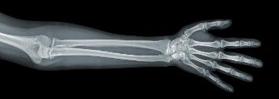 | Solids, liquid and gases  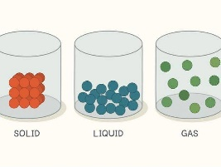 |  | Plants and their food production  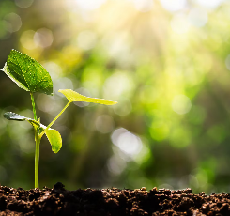
Year 4 | Mixtures and separating them  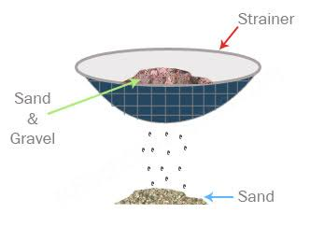 | Digestion: How the body gets nutrients into the blood  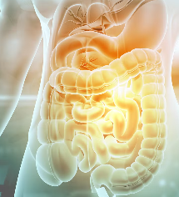 |  | Living things  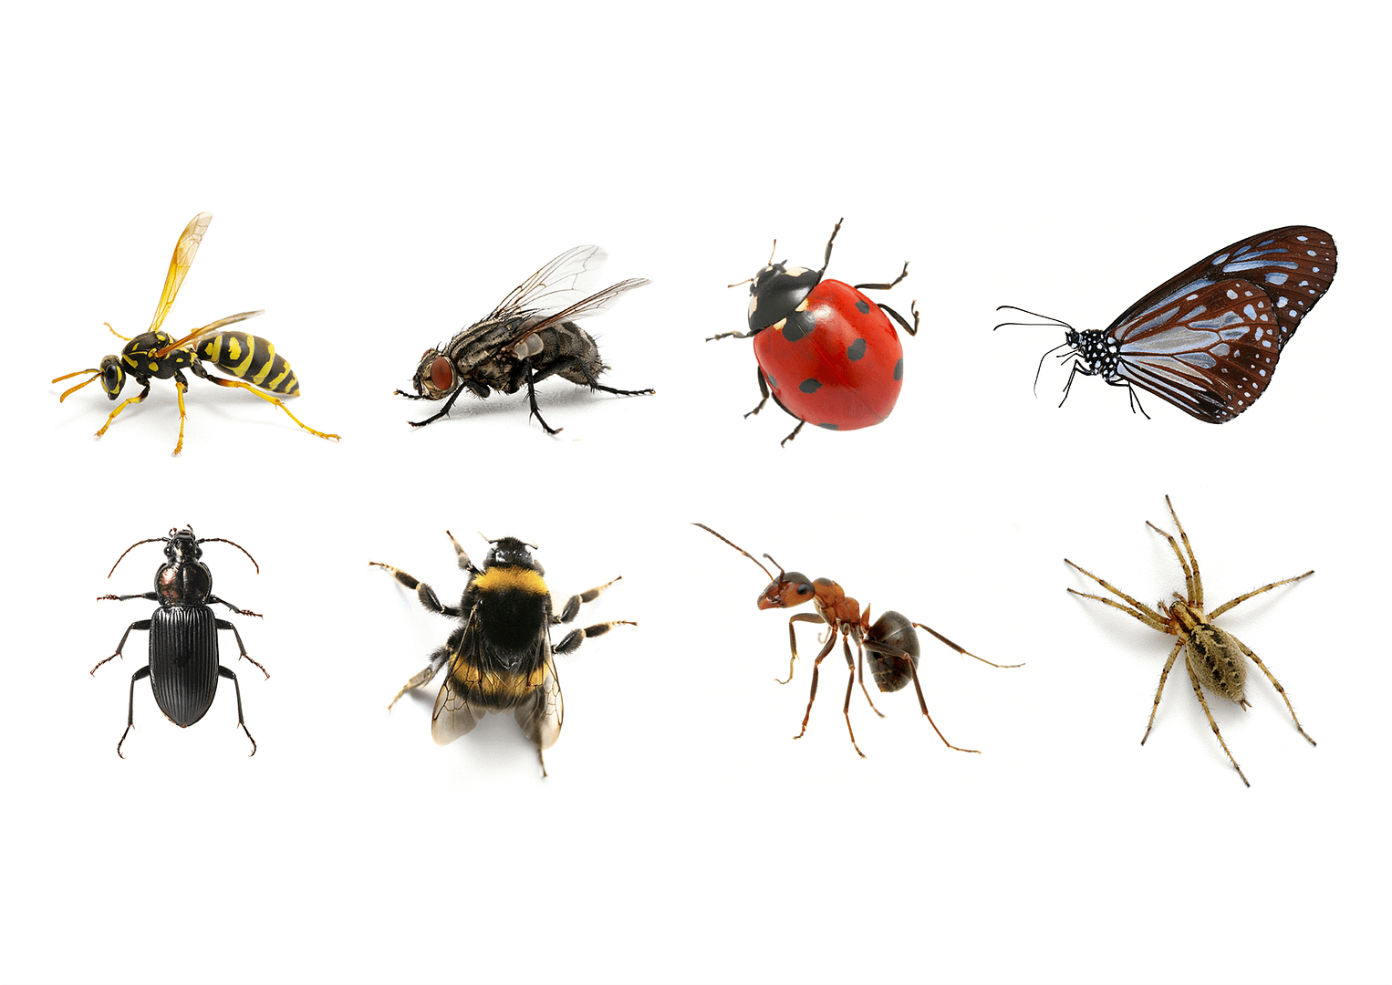 | Plant reproduction  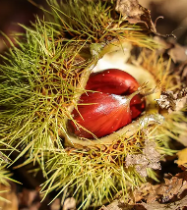 | Making electrical circuits work  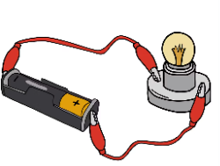
Year 5 | Fossils, geological time and classification  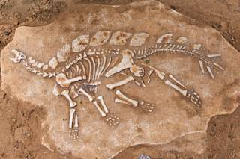 | Space and gravity  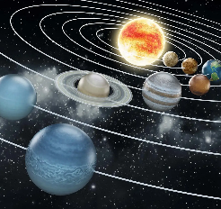 |  | Making new substances  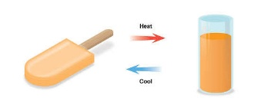 | Forces that oppose motion  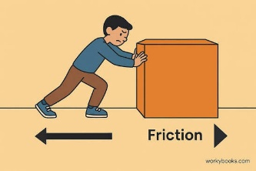 |  | Circulation: how substances get to where they are needed in the body  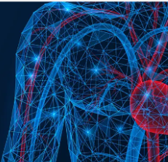
Year 6 | Evolution and natural selection  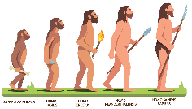 |  | How Light behaves  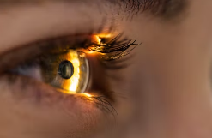 |  | Controlling electrical circuits  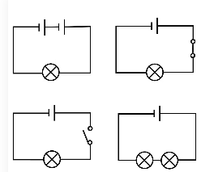 | How sounds are made, travel and can be changed  