
Long term overview – DT

 | Autumn 1st | Autumn 2nd | Spring 1st | Spring 2nd | Summer 1st | Summer 2nd
Year 3 |  | Mechanical systems: Pneumatic toys  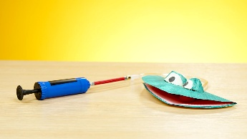 |  | Digital world: Wearable tech  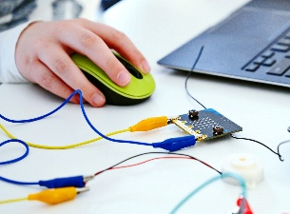 |  | Cooking and nutrition: Eating seasonally  
Year 4 | Textiles: Egyptian collars  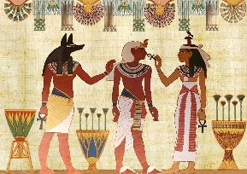 |  | Structures: Pavilions  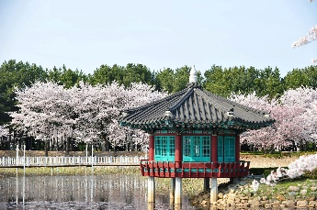 |  |  | 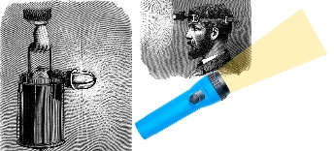  Electrical systems: Torches
Year 5 |  | Digital world: Monitoring devices   | Mechanical systems: Slingshot car  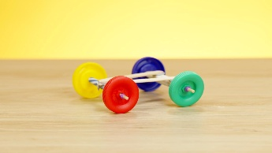 |  | Cooking and nutrition: Adapting a recipe  
Year 6 | Structures: Playground pioneers  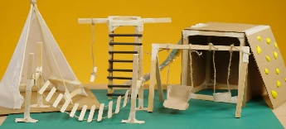 |  | Electrical systems: Steady hand game  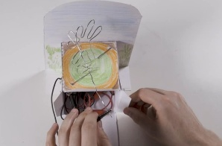 |  | Textiles: Stuffed toys  