
Long term overview – Geography

 | Autumn 1st | Autumn 2nd | Spring 1st | Spring 2nd | Summer 1st | Summer 2nd
Year 3 | Should the Douglas family move to Kempshott?  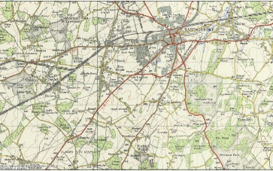 |  | Where do mountains come from?  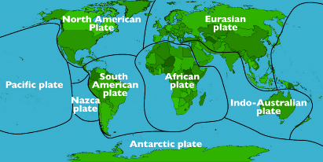 |  | Why do we not have rainforests in the UK?  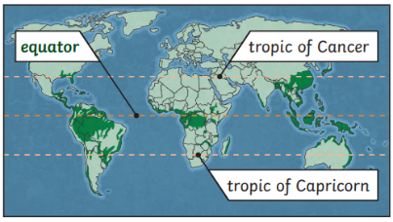
Year 4 | How does our local river change from source to mouth?  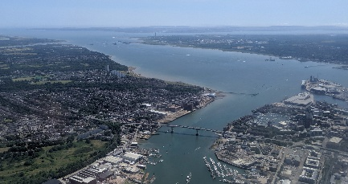 |  | Why is Alencon the twin town of Basingstoke?  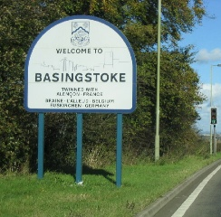
Year 5 |  |  | Where did my ice cream come from and what is the environmental impact?   |  | 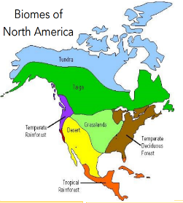  What are the natural resources of North America?
Year 6 | Where would be the best place to build my playground?  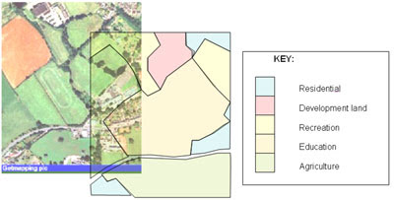 |  | What is the ring of fire and where is it?  