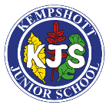
Art and Design – Long-Term Curriculum Overview
 | Autumn | Spring | Summer
Year 3 | 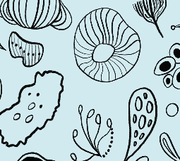  Developing drawing skills | Painting and mixed media: exploring texture with paint and collage  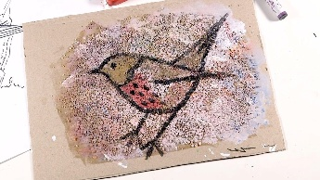 | Sculpture and 3D: Mega materials  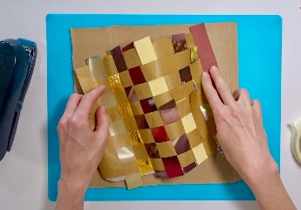
Year 4 | Drawing: Exploring tone, texture and proportion  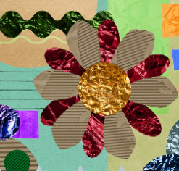 | Painting and mixed media: Light and dark  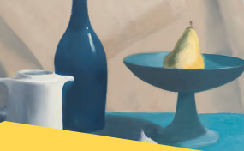 | Craft and design: Fabric of nature  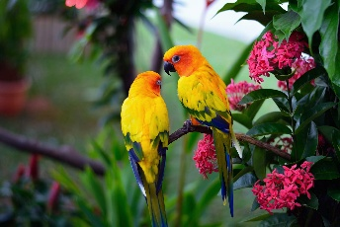
Year 5 | 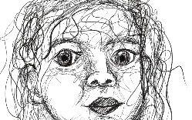  Drawing: Depth, emotion and movement | Painting and mixed media: Portraits  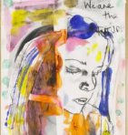 | 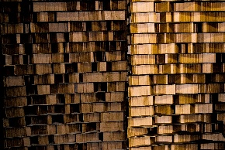  Sculpture: Making memories
Year 6 | Painting and mixed media: World in Watercolour  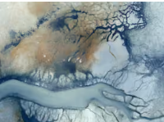 | Drawing: Expressing ideas  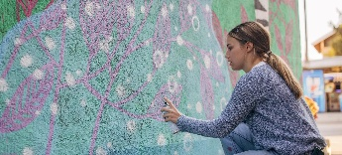 | Craft and design: Photo opportunity  